# Artificial Intelligence: AI For Business

**What you'll learn-and how you can apply it**

* What artificial intelligence is and isn't
* Why and how AI can be used to achieve business goals
* How to prepare for AI projects, including organizationally
* Typical costs, assumptions, risks, and considerations
* The current state of AI and the hype surrounding it
* The potential future of AI

**At a high-level participants will be able to**:

* Understand why and how AI can be used to achieve business goals
* Leverage concepts learned to help guide preparation and decisions for successful pursuit of AI projects
* Understand the difference between AI hype and reality

**This course is taught continuously for an hour and will consist of the topics listed below. Questions will be answered throughout the course, where possible, and time frame will be allotted at the end for Q&A.**

* Course Overview
* What is AI?
* Why AI for Business?
* How is AI Used?
* Organizational Readiness For AI
* The data powering AI
* The costs of AI
* Assumptions and Risks
* Considerations
* AI… Hype or Reality?
* The Future of AI

**Artificial Intelligence - An Overview of AI and Machine Learning**

**What you'll learn-and how you can apply it**

* Definitions of AI and machine learning, along with related concepts
* Some of the different AI and machine learning types and algorithms
* Common processes applied to AI and machine learning projects
* Common tradeoffs and considerations associated with AI and machine learning

**At a high-level, you will be able to**:

* Understand what AI and machine learning means
* Understand the different types of AI and machine learning techniques and algorithms
* Understand some of the common tradeoffs and considerations associated with AI and machine learning

**This course is taught continuously for an hour and will consist of the topics listed below. Questions will be answered throughout the course, where possible, and time frame will be allotted at the end for Q&A.**

* AI Definitions and Related Concepts
* Machine Learning Definition
* Machine Learning Types and Algorithms
* AI Types and Algorithms
* AI and Machine Learning Process
* Tradeoffs and Considerations

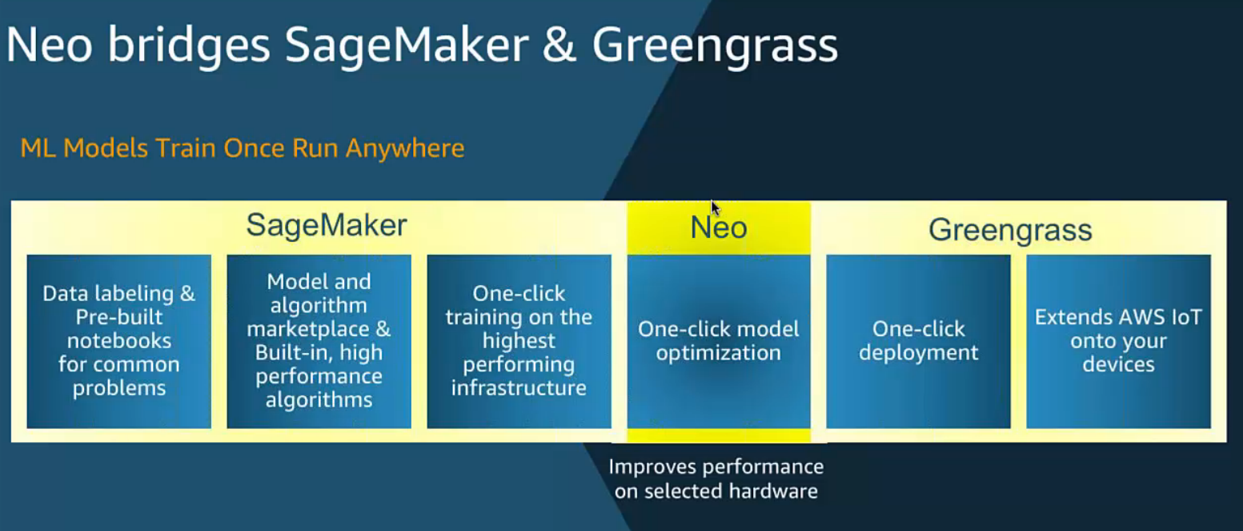

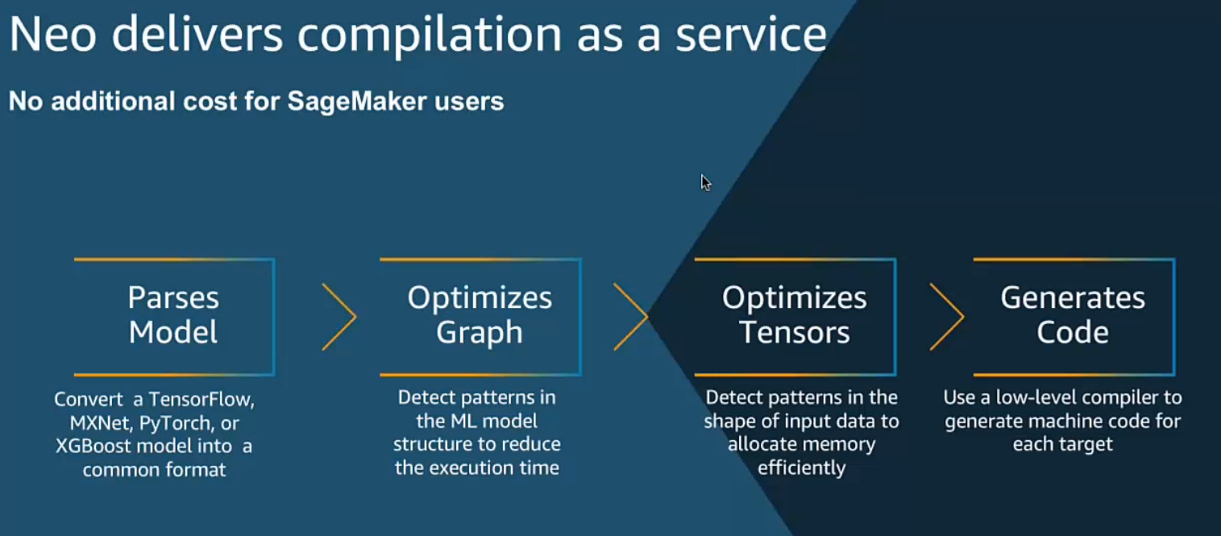

Amazon Elastic Inference for fast inference at low cost

Amazon SageMaker Neo for training models once and running them anywhere

Automatic Model Tuning for the best model accuracy

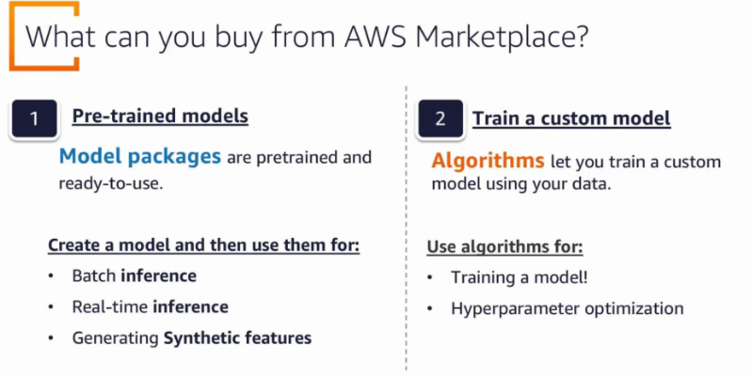

Use Case

Model

Data

